CASE tipa operatori

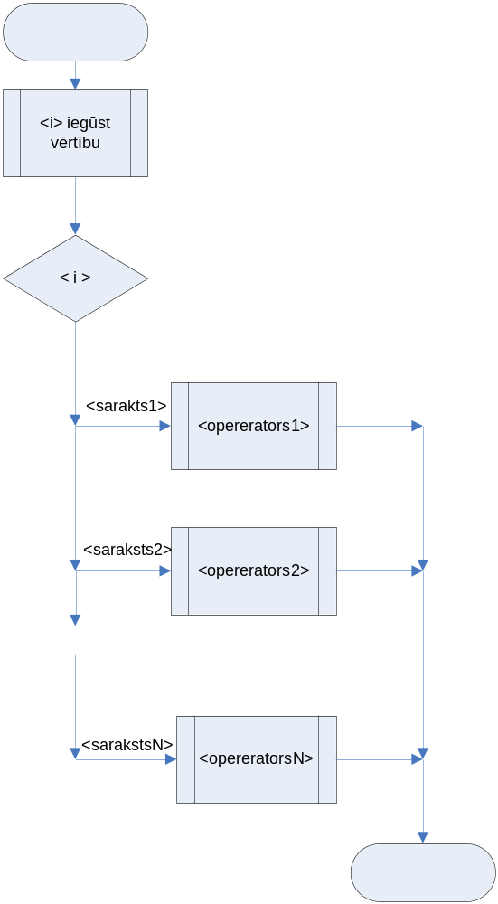
<i iegūst vērtību>
case (i) of
1, 2, 3: read(k);
17: writeln( ‘Ievadiits 17’);
22, 33, 345: begin
k:=k+1;
s:=u;
end;
end;
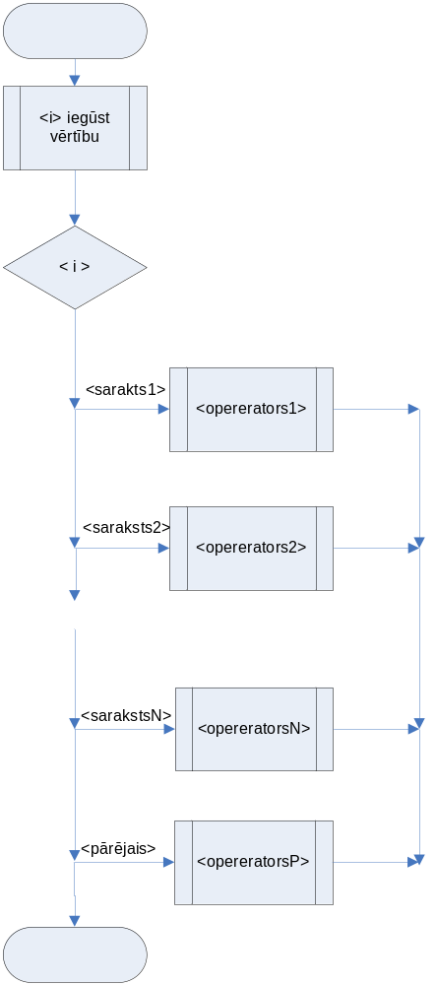
<i iegūst vērtību>
case (i) of
1, 2, 3: read(k);
17: writeln( ‘Ievadiits 17’);
22, 33, 345: begin
k:=k+1;
s:=u;
end;
else writeln(‘ Neparedzēts’);
end;
Pielietojumi

Elementārs MENU

program CASEmenu;
var action: integer;
label Menu, ENDING;
begin
MENU:
writeln('Ievadi izpildaamaas darbiibas numuru');
writeln('1 - datu ievade');
writeln('2 - areekins');
writeln('3 - rezultatu izvade');
writeln('999 - beigt darbu');
read ( Action);
case (Action) of
1: begin ..... end;
2: begin ..... end;
3: begin ......end;
999: begin writeln(' beidzam darbu'); goto ENDING; end;
else
writeln('Darbiba ar numuru', Action, 'nav paredzeeta');
end;
goto MENU;
ENDING:
end.

Datu ”zortēšana”

case Ch of
'A'..'Z', 'a'..'z': WriteLn('Letter');
'0'..'9': WriteLn('Digit');
'+', '-', '*', '/': WriteLn('Operator');
else
WriteLn('Special character');
end;

Aprēķini

var i, j, k, m, s :integer;
label CASEPOINT;
begin
k:=21;
m:=k mod 4;
CASEPOINT: case m of
1, 5 : begin m:=m+9; S:=0; goto CASEPOINT end;
2, 10: begin m:=m+15; S:=-1000; end;
else begin m:=m-5; goto CASEPOINT; end;
end;
writeln( 'm=', m, ' S=', S);
i:=2; S:=100;
for j:=1 to 10 do
begin
if i<4 then i:=i+5 else i:=i+1;
for k:=1 to 5 do
begin
i:=i+1;
S:=S-10;
end;
end;
writeln( 'i=', i, ' S=', S);
end.

m= 25 s= -1000
i=66 s= -400

var i, j, k, m, s :integer;
label CASEPOINT;
begin
k:=19;
m:=k div 4;
CASEPOINT: case m of
1, 5 : begin m:=m+9; S:=0; goto CASEPOINT end;
2, 10: begin m:=m+15; S:=-1000; end;
else begin m:=m-5; goto CASEPOINT; end;
end;
writeln( 'm=', m, ' S=', S);
i:=2; S:=100;
for j:=1 to 10 do
begin
if i<4 then i:=i+5 else i:=i+1;
for k:=1 to 5 do
begin
i:=i+1;
S:=S-10;
end;
end;
writeln( 'i=', i, ' S=', S);
end.

m= ?? s= ?????
i=XX s= XXX

